Queries Output
- Show first name, last name, and gender of patients who's gender is 'M'
SELECT first_name, last_name, gender
FROM patients
WHERE gender = 'M';
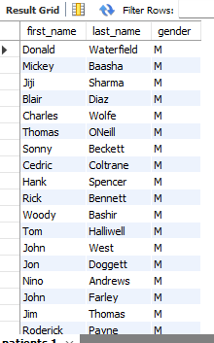

- Show first name and last name of patients who does not have allergies.
SELECT first_name, last_name, allergies
FROM patients
WHERE allergies IS NULL;
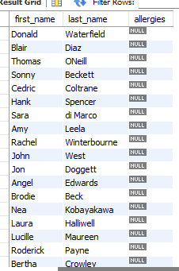

- Show first name of patients that start with the letter 'C'
SELECT first_name
FROM patients
WHERE first_name LIKE 'C%';
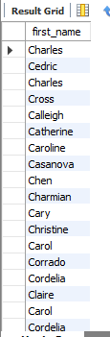

- Show first name and last name of patients that weight within the range of 100 to 120 (inclusive)
SELECT first_name, last_name, weight
FROM patients
WHERE weight BETWEEN 100 AND 120;
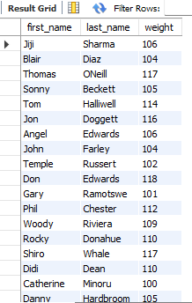

- Update the patients table for the allergies column. If the patient's allergies is null then replace it with 'NKA'
UPDATE patients
SET allergies ='NKA'
WHERE allergies IS NULL;

SELECT * FROM patients
WHERE allergies = 'NKA';
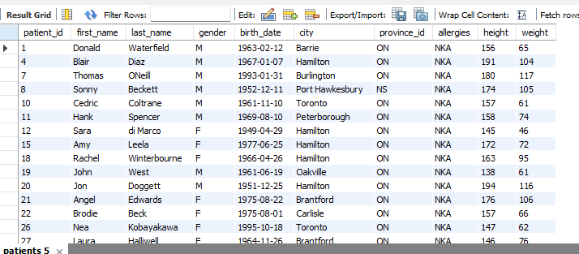

- Show first name and last name concatenated into one column to show their full name.
SELECT CONCAT(first_name, ' ', last_name) AS full_name
FROM patients;


- Show first name, last name, and the full province name of each patient
SELECT p.first_name,
p.last_name,
pn.province_name
FROM patients AS p
INNER JOIN province_names AS pn
ON p.province_id = pn.province_id;
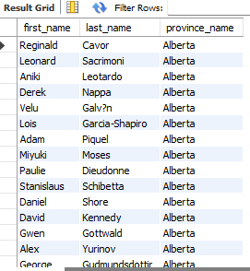

- Show how many patients have a birth_date with 2010 as the birth year.
SELECT COUNT(patient_id) AS total_patient
FROM patients
WHERE YEAR(birth_date) = 2010;
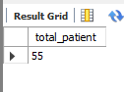

- Show the first_name, last_name, and height of the patient with the greatest height.
SELECT first_name, last_name, height
FROM patients
ORDER BY height DESC LIMIT 1;
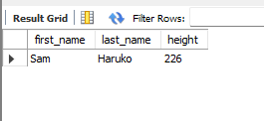

- Show all columns for patients who have one of the following patient_ids: 1,45,534,879,1000
SELECT * FROM patients
WHERE patient_id IN(1,45,534,879,1000);
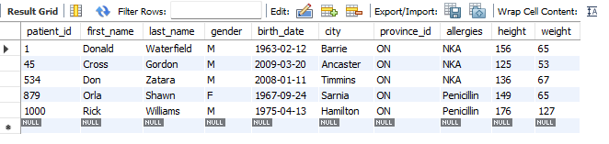

- Show the total number of admissions
SELECT COUNT(*) AS total_admission
FROM admissions;


- Show all the columns from admissions where the patient was admitted and discharged on the same day.
SELECT *
FROM admissions
WHERE admission_date = discharge_date;
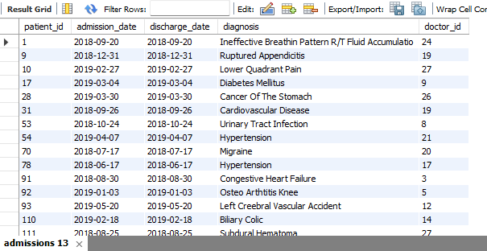

- Show the total number of admissions for patient_id 579.
SELECT COUNT(*) AS total_count
FROM admissions
WHERE patient_id = 579;
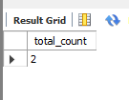

- Based on the cities that our patients live in, show unique cities that are in province_id 'NS'?
SELECT DISTINCT(city)
FROM patients
WHERE province_id = 'NS';
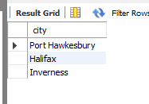

- Write a query to find the first_name, last name and birth date of patients who have height more than 160 and weight more than 70.

SELECT first_name, last_name, birth_date
FROM patients
WHERE height > 160
AND weight > 70;
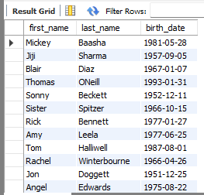

- Show unique birth years from patients and order them by ascending.
SELECT DISTINCT YEAR(birth_date) AS birth_year
FROM patients
ORDER BY birth_year ASC;
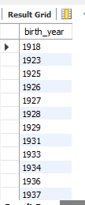

- Show unique first names from the patients table which only occurs once in the list.
SELECT first_name
FROM patients
GROUP BY first_name
HAVING COUNT(first_name) =1;


- Show patient_id and first_name from patients where their first_name start and ends with 's' and is at least 6 characters long.

SELECT patient_id, first_name
FROM patients
WHERE first_name LIKE 'S%'
AND first_name LIKE '%S'
AND LENGTH(first_name) >= 6;
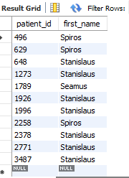

- Show patient_id, first_name, last_name from patients whos diagnosis is 'Dementia'.

SELECT p.patient_id,
p.first_name,
p.last_name,
a.diagnosis
FROM patients AS p
INNER JOIN admissions AS a
ON p.patient_id = a.patient_id
WHERE a.diagnosis ="Dementia";
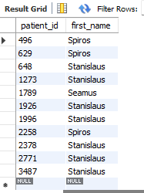

- Display every patient's first_name. Order the list by the length of each name and then by alphbetically.

SELECT first_name
FROM patients
ORDER BY LENGTH(first_name) ASC,
first_name ASC;


- Show the total amount of male patients and the total amount of female patients in the patients table. Display the two results in the same row.

SELECT
SUM(CASE WHEN gender = "M" THEN 1 ELSE 0 END) AS male_count,
SUM(CASE WHEN gender = "F" THEN 1 ELSE 0 END) AS female_count
FROM patients;
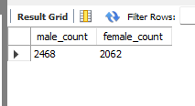

- Show patient_id, diagnosis from admissions. Find patients admitted multiple times for the same diagnosis.

SELECT patient_id,
diagnosis
FROM admissions
GROUP BY patient_id, diagnosis
HAVING COUNT(*) > 1;
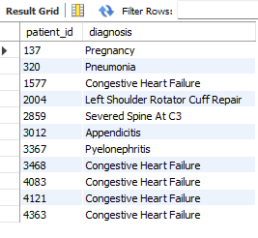

- Show patient_id, diagnosis from admissions. Find patients admitted multiple times for the same diagnosis.

SELECT patient_id,
diagnosis
FROM admissions
GROUP BY patient_id, diagnosis
HAVING COUNT(*) > 1;
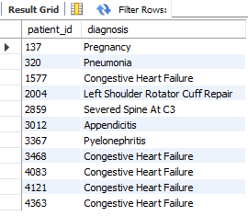

- Show the city and the total number of patients in the city. Order from most to least patients and then by city name ascending.

SELECT city, COUNT(patient_id) total_patient
FROM patients
GROUP BY city
ORDER BY total_patient DESC,
city ASC;
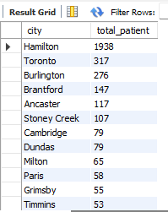

- Show first name, last name and role of every person that is either patient or doctor. The roles are either "Patient" or "Doctor"
SELECT first_name, last_name, 'patient' AS role
FROM patients
UNION ALL
SELECT first_name, last_name, 'doctor' AS role
FROM doctors;
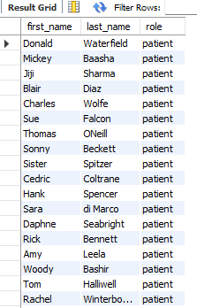

- Show all allergies ordered by popularity. Remove NULL values from query.
SELECT allergies, COUNT(*) AS total_patients
FROM patients
WHERE allergies IS NOT NULL
GROUP BY allergies
ORDER BY total_patients DESC;

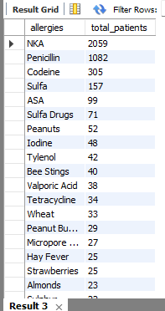

- Show all patient's first_name, last_name, and birth_date who were born in the 1970s decade. Sort the list starting from the earliest birth_date.

SELECT first_name, last_name, birth_date
FROM patients
WHERE birth_date BETWEEN '1970-01-01' AND '1979-12-31'
ORDER BY birth_date ASC;


- We want to display each patient's full name in a single column. Their last_name in all upper letters must appear first, then first_name in all lower case letters. Separate the last_name and first_name with a comma. Order the list by the first_name in decending order

SELECT CONCAT(UCASE(last_name), ',', LCASE(first_name)) AS full_name
FROM patients
ORDER BY first_name DESC;


- Show the province_id(s), sum of height; where the total sum of its patient's height is greater than or equal to 7,000.

SELECT province_id, SUM(height) AS total_height
FROM patients
GROUP BY province_id
HAVING SUM(height) >= 7000;
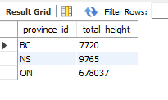
- Show the difference between the largest weight and smallest weight for patients with the last name 'Maroni'

SELECT
(SELECT MAX(weight) FROM patients WHERE last_name = 'Maroni') -
(SELECT MIN(weight) FROM patients WHERE last_name = 'Maroni')
AS weight_difference;
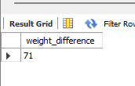

- Show all of the days of the month (1-31) and how many admission_dates occurred on that day. Sort by the day with most admissions to least admissions.

SELECT
DAY(admission_date) AS day_of_month,
COUNT(*) AS total_admissions
FROM admissions
GROUP BY DAY(admission_date)
ORDER BY day_of_month;
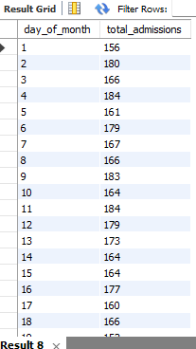

- Show all of the patients grouped into weight groups. Show the total amount of patients in each weight group. Order the list by the weight group decending.

SELECT
FLOOR(weight / 10) * 10 AS weight_group,
COUNT(*) AS total_patients
FROM patients
GROUP BY weight_group
ORDER BY weight_group DESC;
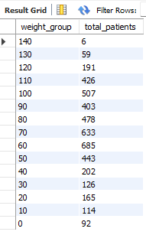

- Show patient_id, weight, height, isObese from the patients table. Display isObese as a boolean 0 or 1. Obese is defined as weight(kg)/(height(m). Weight is in units kg. Height is in units cm.

SELECT
patient_id,
weight,
height,
(weight / ((height / 100) * (height / 100)) >= 30) AS isObese
FROM patients;
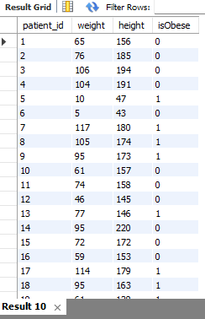

- Show patient_id, first_name, last_name, and attending doctor's specialty. Show only the patients who has a diagnosis as 'Epilepsy' and the doctor's first name is 'Lisa'.

SELECT p.patient_id,
p.first_name,
p.last_name,
a.diagnosis,
d.specialty,
d.first_name
FROM patients AS p
JOIN admissions AS a
ON p.patient_id = a.patient_id
JOIN doctors AS d
On a.doctor_id = d.doctor_id
WHERE diagnosis = 'Epilepsy'
AND d.first_name = 'Lisa';

